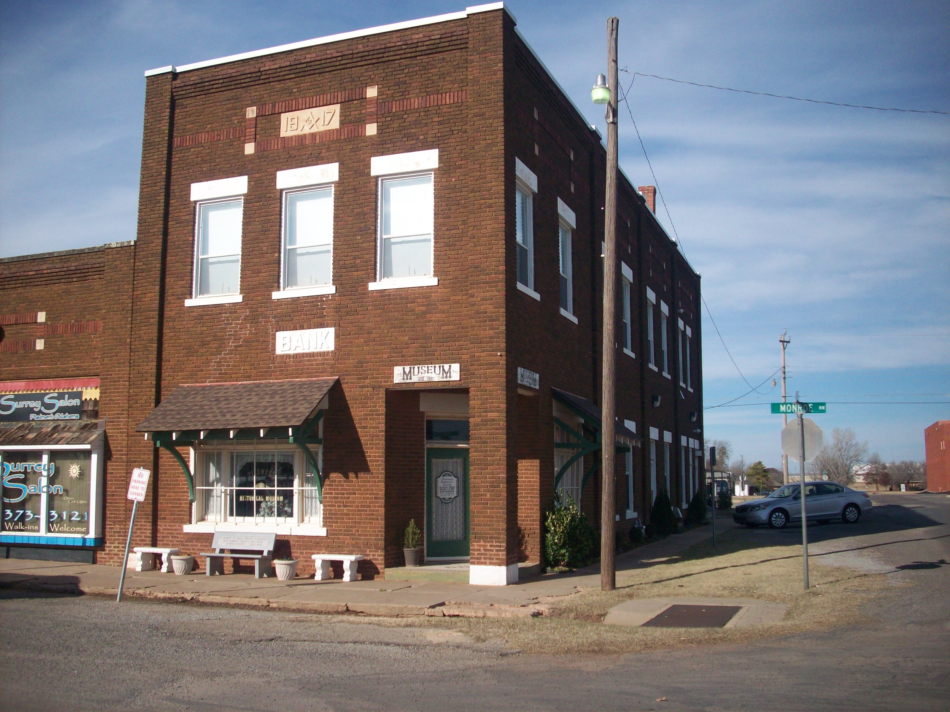

Piedmont
Historical Society
P.O. Box 233
Piedmont, OK 73078

www.PiedmontHistoricalSociety.org

If you have questions concerning the Piedmont Historical Society or our website – list them here.

________________________________________________________________

________________________________________________________________________

________________________________________________________________________

________________________________________________________________________

Please list your suggestions for improvements to the Piedmont Historical Society Programs, operations and/or additional information you would like to see on our website.

________________________________________________________________

________________________________________________________________________

________________________________________________________________________

________________________________________________________________________

Send your questions &/or Suggestions to the address above or

E-mail: dwillis@donwillis.com Fax: 405 495-2043

