Unique Periods in Piedmont's History and Their "Characters.”

Piedmont's history has been conveyed with such descriptive terms as “Piedmont: the Place of Open Spaces and Friendly Faces,” “Piedmont: The Winds of Progress,” etc. Our recent motto contest had as its winner: “Piedmont, Where Community Becomes Family.” But since I am writing this history so that it can be conveyed to children and people at the playground visually, my discussion necessarily focuses on objects or places that brought Piedmont people together. I have made no attempts to bring into discussion objects that are readily visualized now or would be considered modern. Instead, this history focuses on Piedmont's distant past that because of its success has left a legacy that is now defining our future. When people walk through the playground they can actually learn some of Piedmont's history without making much of an effort solely by interacting with the exhibits within the playground.
If I could bullet point these major periods and their characters, I would list these as six main eras:
1). Native Americans/ native animals like bison, coyotes, deer, antelope, etc. mainly before the 1860s.
2). The Chisholm Trail 1867-1884. This 1200-mile-long trail extends from Brownsville, Texas to Abilene, Kansas and was filled with longhorn cattle, cowboys, and chuck wagons.
3). The Land Run and the earliest settlers starting around 1889. Its symbols are covered wagons, settlers, sod houses, and windmills.
4). The railroad comes to town as the St. Louis - El Reno - Western Railroad of 1904. The railroad completed the functional demise of the Chisholm Trail. It created Piedmont proper because many small communities and towns moved their buildings to the one stop named Piedmont midway between El Reno and Guthrie (the latter serving as the Oklahoma Territorial capital). This was a big deal because the Rock Island Line interchanged in El Reno, and therefore Piedmont would be connected to the rest of America by rail via El Reno.
5). Early historic buildings in town:
- Simpson grain elevator and prairie gold: wheat
- Mulvey Mercantile Company, the Wiedemann Store, and Piedmont Mercantile: the stores that "handled almost anything you might want."
- The Piedmont State Bank, which subsequently would become the Piedmont Historical Society building.
- Stover Hall, the center of nightlife for Piedmont citizens from the 1940s through the 60s. The band instruments included a fiddle, guitar, steel guitar, drums, banjo, and bass, and the players and vocalists were native Piedmontians. Vince Gill honored Stover Hall (where his father played) in a song called “Old Time Fiddle.” The fiddle he sings about is on display in the Historical Society Museum.
- Piedmont historical churches, including the earliest Piedmont Methodist Church, the First Baptist Church, and the Bethel Free Methodist Church, among others.
- Piedmont's remaining newspaper the Piedmont-Surrey Gazette. Prior to this Piedmont had the Piedmont Press which started in 1903, the Piedmont News, and the Piedmont Times. The Gazette was started in 1976 and has served the community ever since then. Two papers, the Piedmont Post and the Piedmont Citizen, circulated for short periods.
- The Piedmont schools, most notably the remaining buildings of Simpson Hall, Colette Field house, and Stout Field.
- The windmill display
6). Ancestors’ Celebration: Founder’s Day

In the following pages, I will describe in more detail each of those six main characters and also provide numerous pictures that can be used as well.

Symbol number one is easy: Native Americans and native animals. If you just think of Oklahoma from the musical “Oklahoma” you got it pretty well figured out. A little bit of “Home, Home on the Range” and you’re all set, but the last one I would be stealing from Kansas and its song. We have a lot of coyotes that still roam our farms, and you certainly will see some deer and an occasional puma or mountain lion or at least a bobcat.

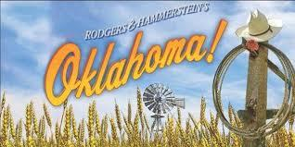

Number two is quite fascinating and if I had my druthers we would emphasize it a lot. The Chisholm Trail was very important to Piedmont, Oklahoma, and the entire Wild West of the USA history, and Piedmont’s location on that trail was incredibly important. What happened was that in the late 1860s soldiers returned from the close of the Civil War to their homes in Texas and suddenly found that their herds of longhorn cattle had increased in size to such a massive number that they were roaming over mainly unfenced land. There in Texas these cattle wouldn't bring much money ($3 a head) but the people of the north were starved for beef and wanted it badly ($30-40 a head). However, the closest railroads were north of Oklahoma Territory and so the cattle needed to be driven across the Oklahoma Territory to get them to market via the rails in Kansas. These cow herders soon learned that they could cross the territory with very little interference over this largely unoccupied land. It only cost them a small amount of money to pay the Indians for safe passage. Over 10 million cattle have been estimated to have traversed the Trail. It was customary to move the cattle just 12 to 15 miles a day because of the existing grass and water that was used to fatten the animals on the drive. One of the most central sources of water on the trail was right in Piedmont at the corner of Piedmont Road and Arrowhead Road today. They were also some large springs on Deer Creek near Piedmont Road as well. The crossings that are particularly important in Piedmont start at the Express ranches north of Yukon and are marked as one goes through Piedmont. All the markers that were laid down by Mr. Bob Klemme of Enid in his Chisholm Trail Study still exist in Piedmont today. The trail is now recognized as the greatest cattle route the world has ever known and has been highlighted as part of the Centennial Corridor for Oklahoma’s Centennial as well as Oklahoma's Historic Chisholm Trail. The markers are only one or two miles west of where our park is actually located. It is certain that longhorn cattle marched right over the land where our park lies today because the watering holes are very near our Park site. Now if you don’t like longhorns (they are the mascots for University of Texas longhorns unfortunately), you may not like that they invaded Piedmont land (which is Cowboy and Sooner country) but C’est la vie!

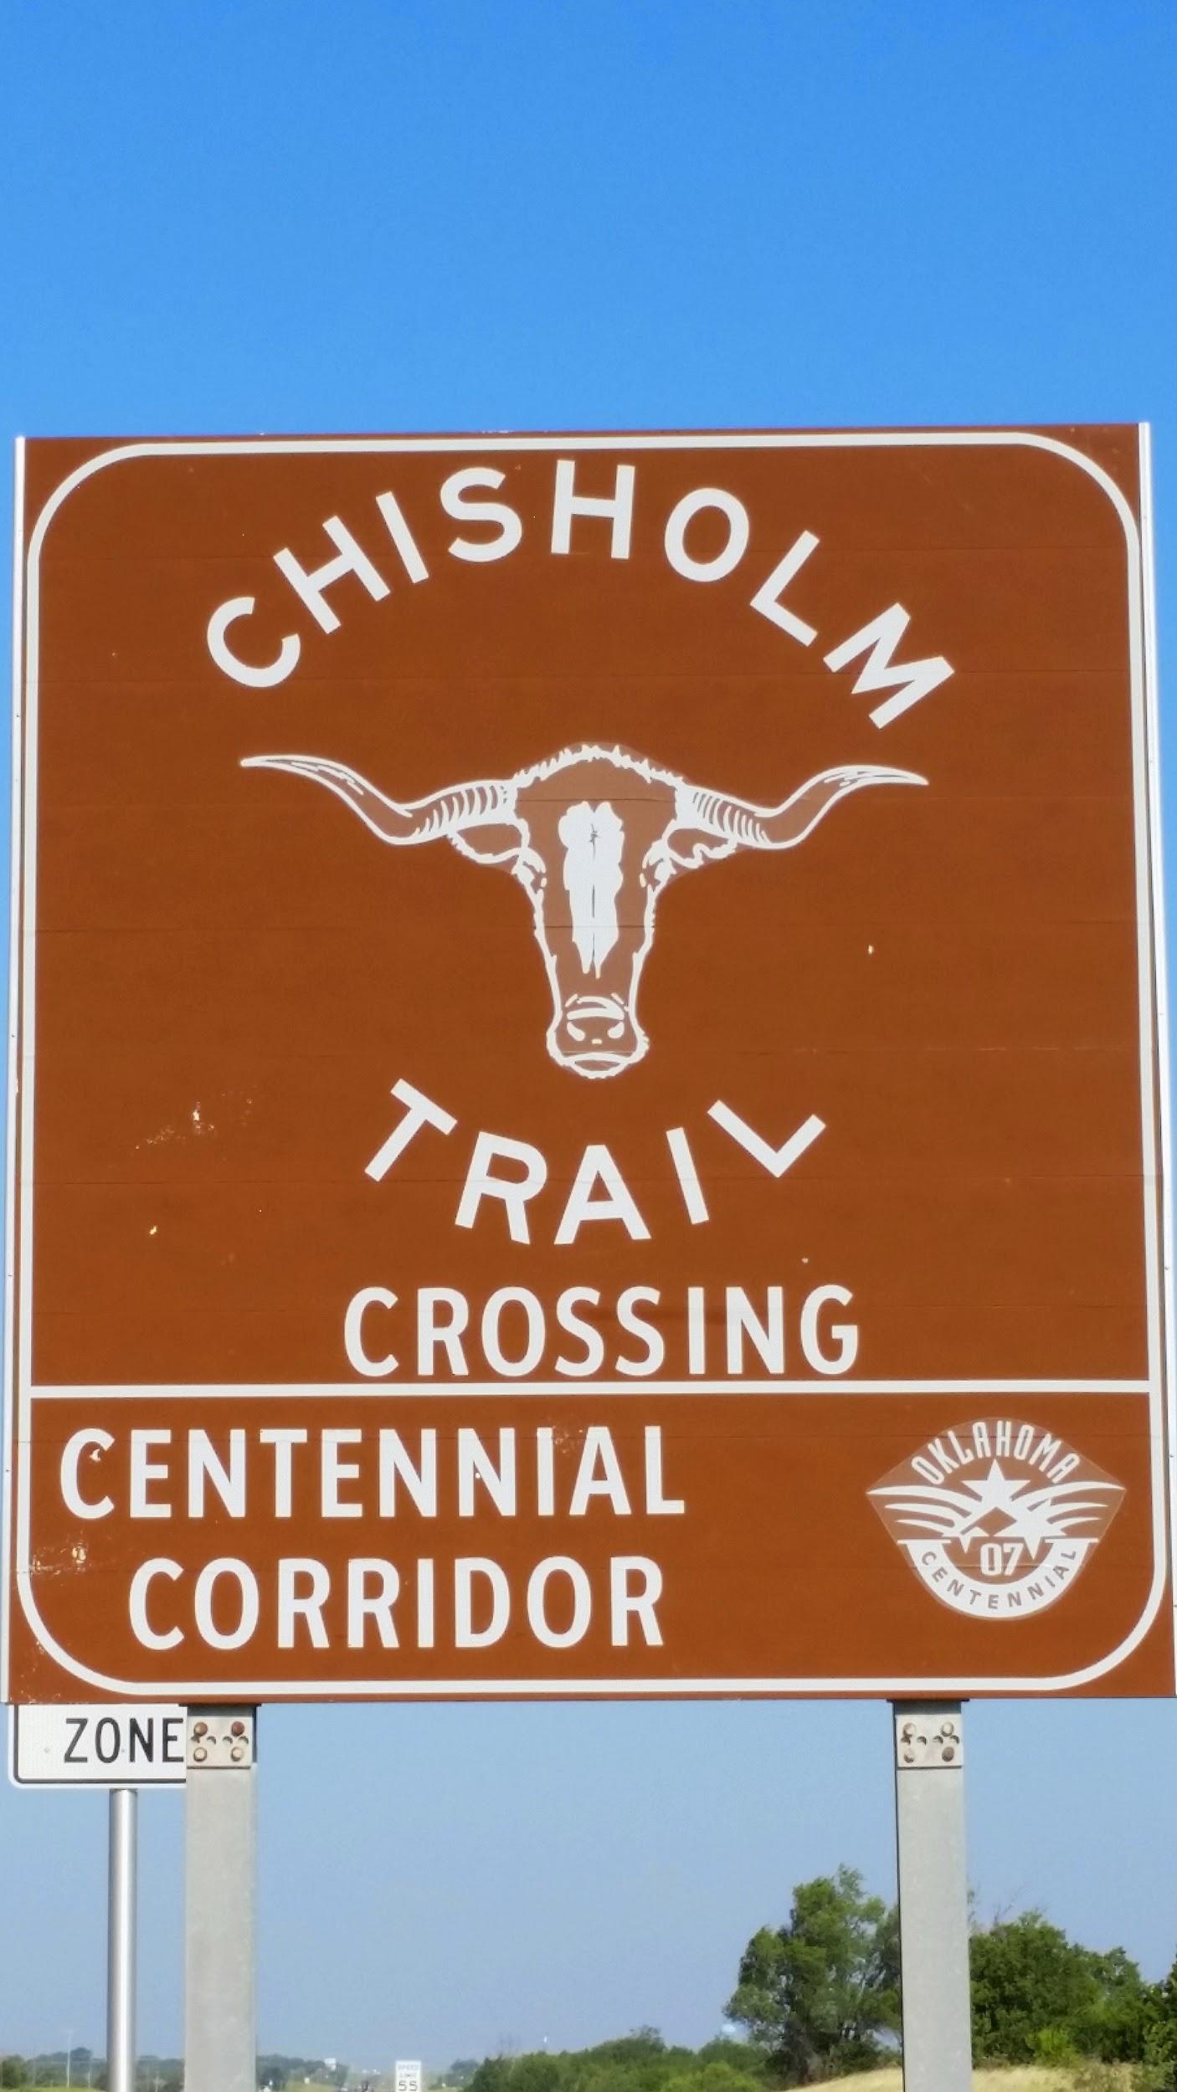

The third category, which is the Land Run, presents the new symbols of covered wagons, settlers, sod houses, and windmills. Because people were marking their plots and starting to create fences around their property during the Land Run, the Chisholm Trail could no longer exist very well except in corridors, but ultimately the bringing of the railroad created the demise of the Chisholm Trail. Sod houses were the norm in early Piedmont, with the only brick buildings in Piedmont early on being the Mulvey Mercantile and the Bank. With all the residents being farmers and/or ranchers, windmills filled our landscape. This is especially commemorated in the windmill display that greets you as you drive north on the main road entering Piedmont from OKC, Highway 4. The land run is commemorated each year in Piedmont public schools by the students who ride in covered wagon races (wagons which the students design and run themselves), dress like settlers, eat frontier food, and participate in other festivities.
We are now at number four which is the railroad comes to town. One needs to understand several things first about our geographical area. First of all, throughout most of America's heartland in the late 1800s and early 1900s towns and cities had to either be on navigable rivers or close to railroads. Piedmont proper did not even exist until 1903 because it had neither of these conditions. People were living in farming communities such as Mathewson, Eda, Herron, Miller, Racine, Ball, and Lockridge. In these small farm communities, you only needed a horse and a horse drawn wagon for your own personal transportation. Automobiles were only owned by the very wealthy and paved roads were almost non-existent.

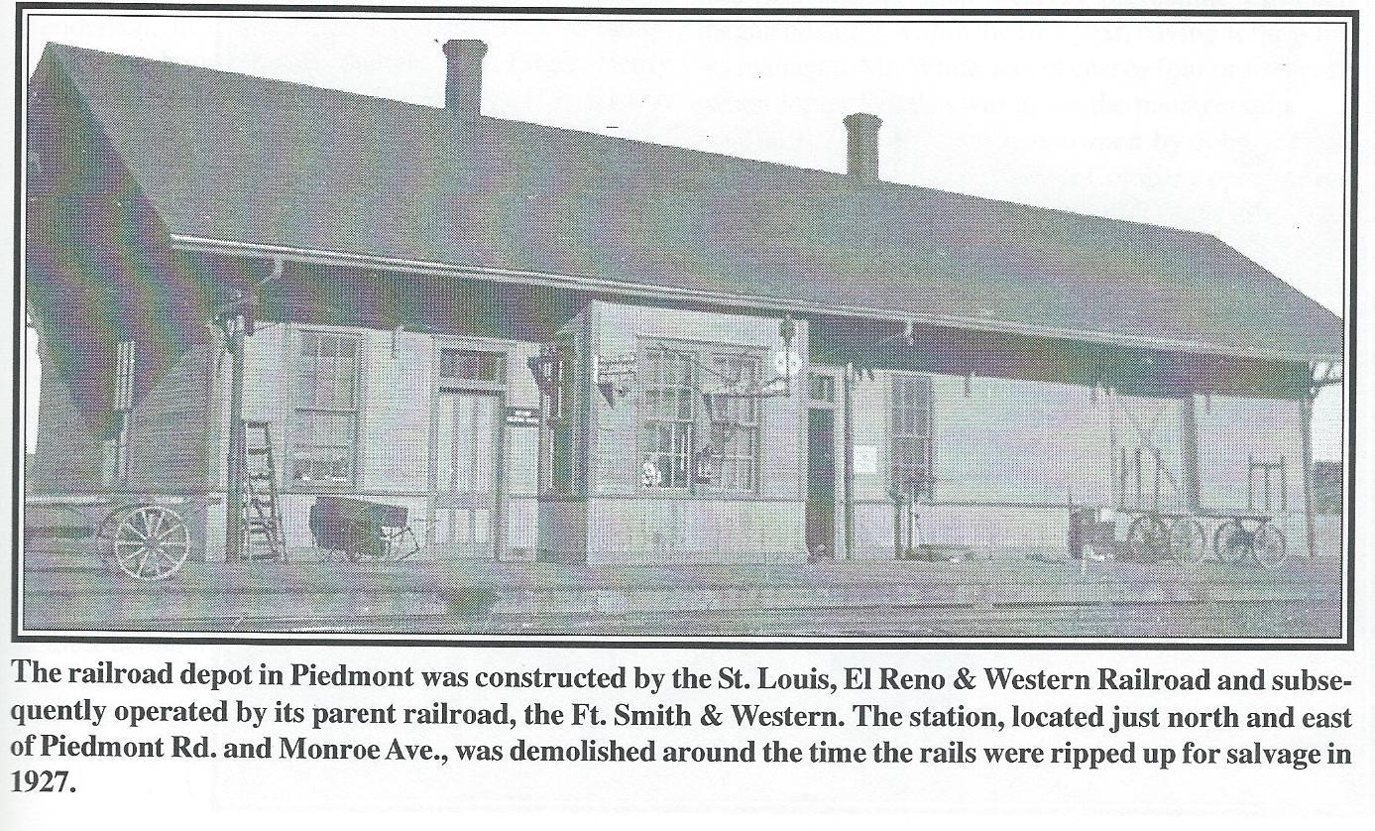
When it was announced that there would be a midpoint station between Guthrie and El Reno on the Saint Louis, El Reno and Western Railroad, the town that almost got called Mildred but later named Piedmont, "at the foot of the hills," was born. Not only did people move from the outlying communities into Piedmont themselves but they also disassembled their buildings and moved them from their original locations for reassembly in Piedmont. In effect, there weren't even ghost towns left behind because the towns themselves moved right to the railroad line. The presence of the railroad had a tremendous effect in creating an economic boom in Piedmont, but due to personal situations among management, the optimism was not fully realized. The line itself became an extension of the Fort Smith and Western Railroad and the owners paid much more attention to other lines that they developed. This lack of attention and effort by management translated into low ridership and weak freight traffic, making the rail line eventually obsolete after a flood in 1920 that destroyed one of the main bridges. Real service stopped in 1923, sputtered again in the early 1930s, and then finally “gave up the ghost” in 1936. However, the presence of the railroad unified many of the communities in the area into a single town. The fact that Guthrie lost its title as capital of the Oklahoma Territory to Oklahoma City as the new capital for the state of Oklahoma also promoted the demise of this rail line. Piedmont would therefore remain a smaller farming community for many years until a big surge in the 1970s, ironically created when the Piedmont Municipal Authority brought potable water throughout a very large area that now serves the needs of the city of Piedmont and beyond.

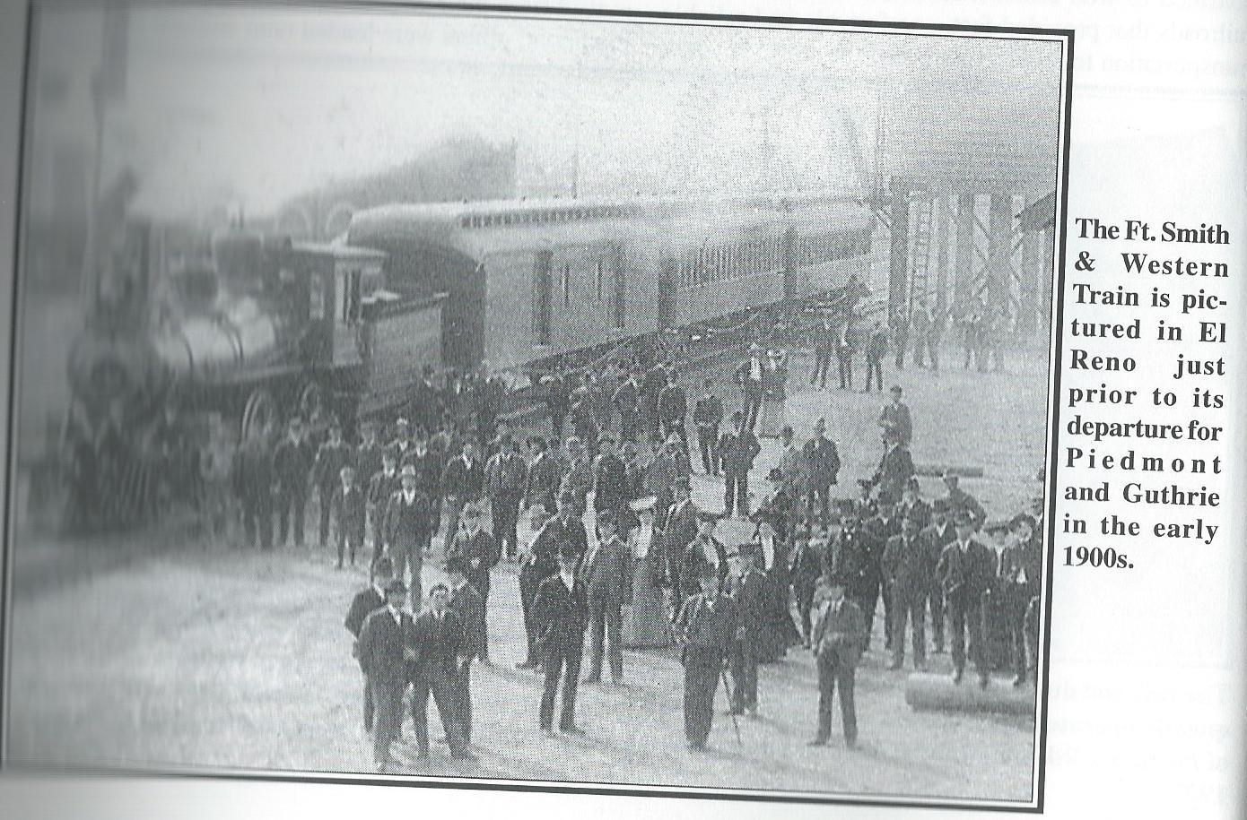

The fifth section includes some of the early historic buildings. I will try to just give you a sentence or two on each one and there are other sources that I can share with you if you are interested. The first one historically is the Simpson grain elevator and prairie gold. The building of the railroad in Piedmont in 1903 clearly provoked the building of these grain elevators for handling the golden wheat from the best prairies of Canadian County. There were several early owners of grain elevators, but the most persistent owner has been the Simpsons, with a sample still standing today. It has become a marker for the city because of its central location and its height, and incidentally it had a spur of the railroad coming directly into it as well as scales for weighing grain and an ice house. I've included a picture for your review.

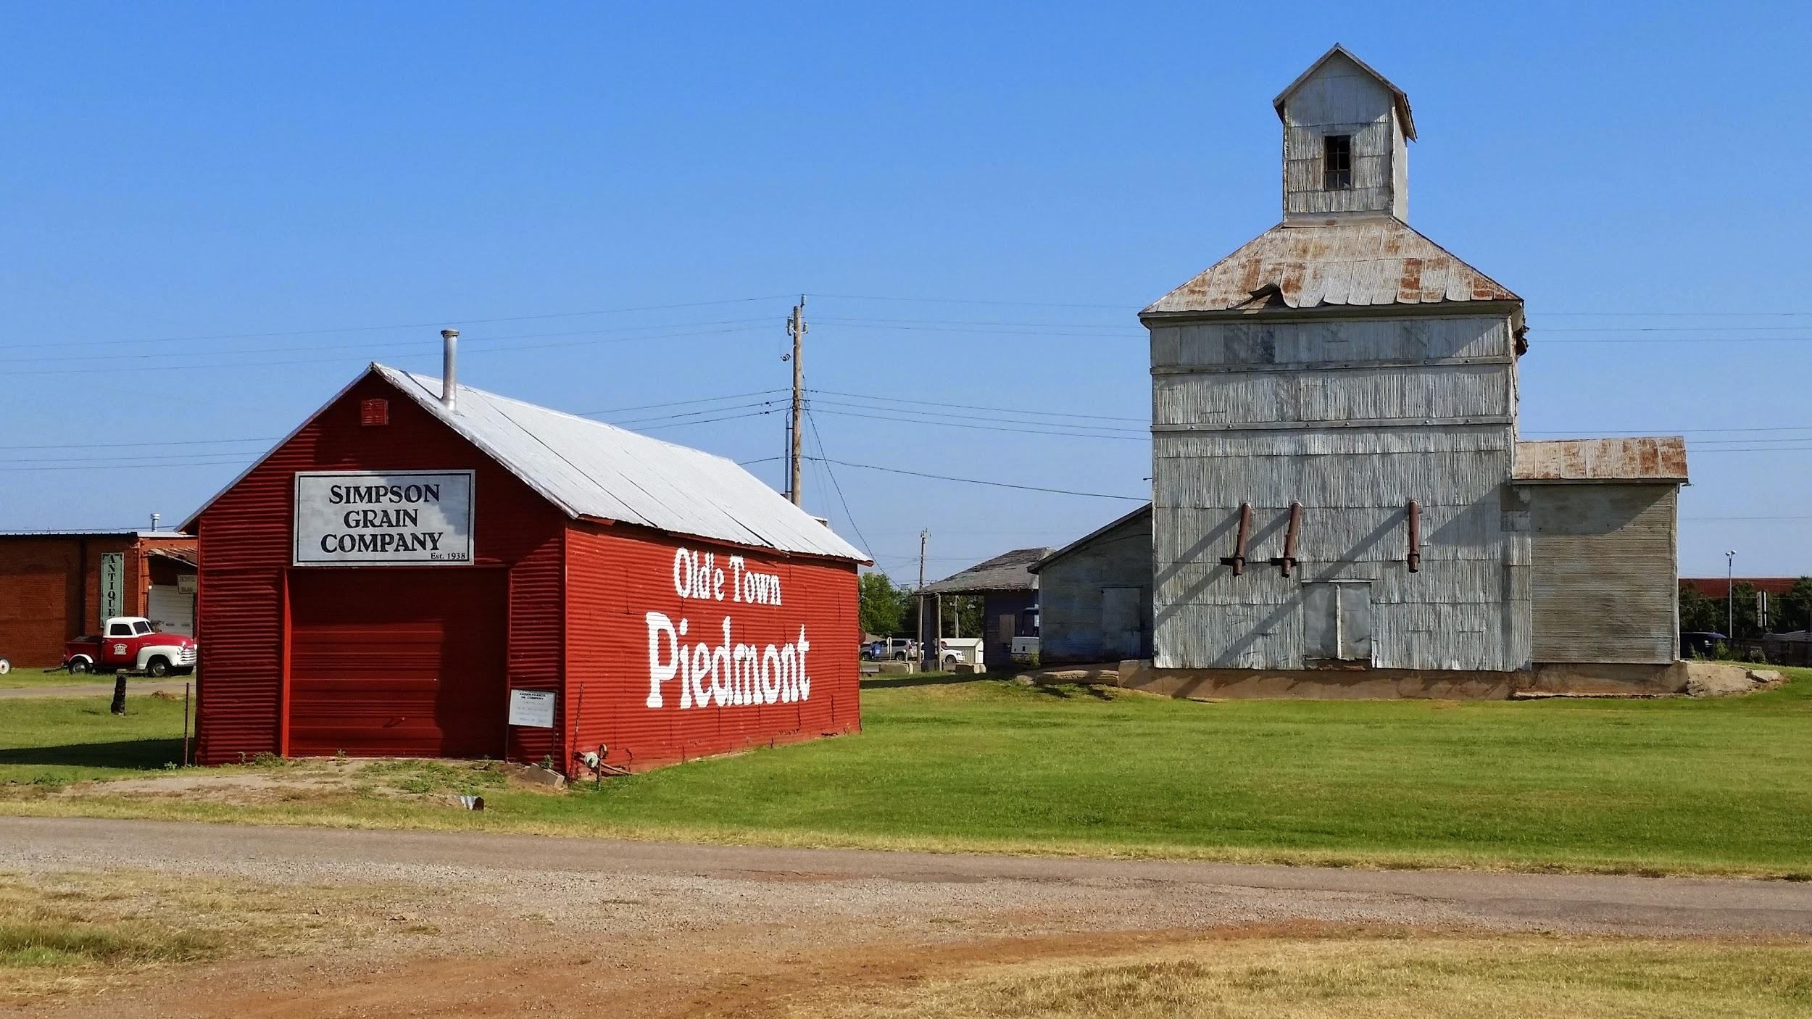

The Mulvey Mercantile Building was absolutely amazing. In the 1910s, we see a store that handled hardware, groceries, and shoes, and had a soda and ice cream fountain, a furniture and an implement business, and an undertaking parlor. In the 1920s, we see the Wiedemann family taking this over and adding numerous other amenities including a blacksmith shop, a tire, gasoline, and propane business, a Ford and John Deere agency, and several other components. In the mid-1920s, the Wiedemanns went ahead and installed the first radio in Piedmont, setting it up with loudspeakers to the outside so that the town could listen. Not to be outdone, the Piedmont Mercantile would buy the first TV and put it in the store window so that patrons could see it outside. In a sense, the Mulvey Mercantile, the Piedmont Mercantile, and the subsequent Wiedemann store all served as the center of ordinary life in Piedmont and are still serving such a function as the Old Store does today.

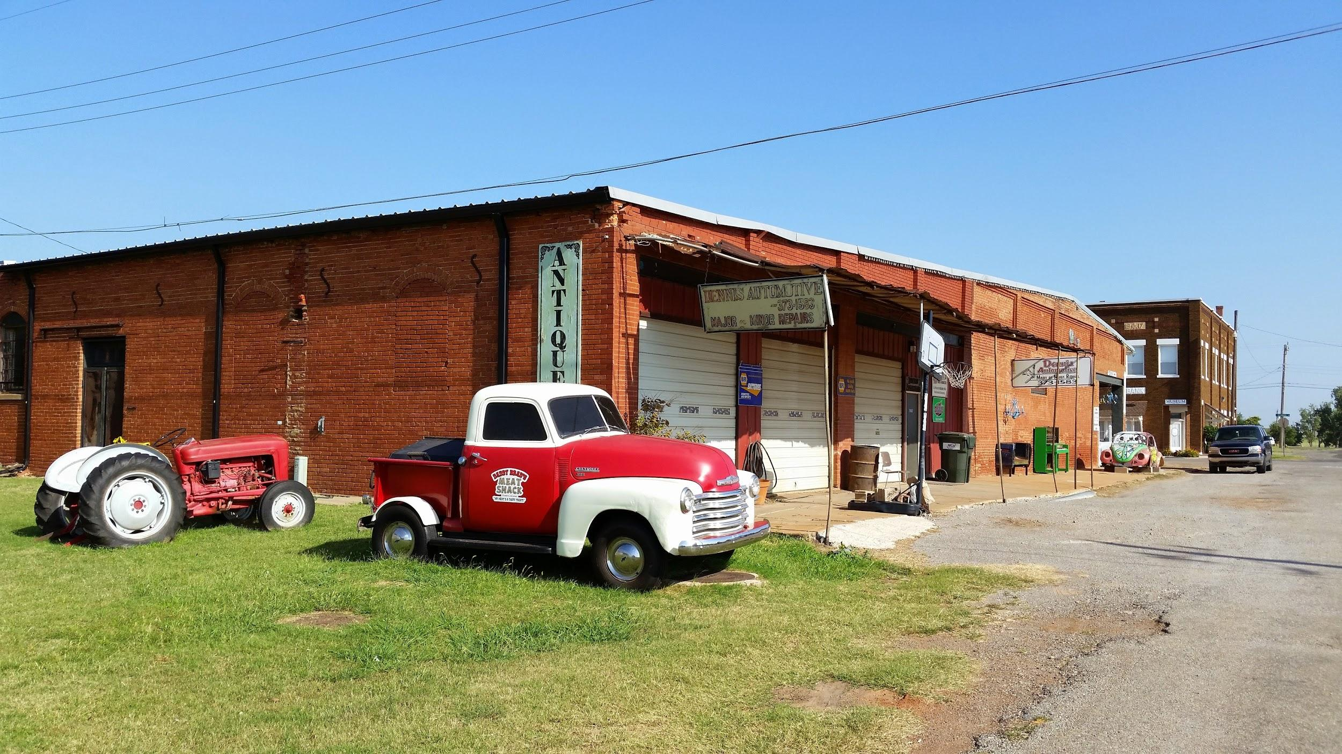
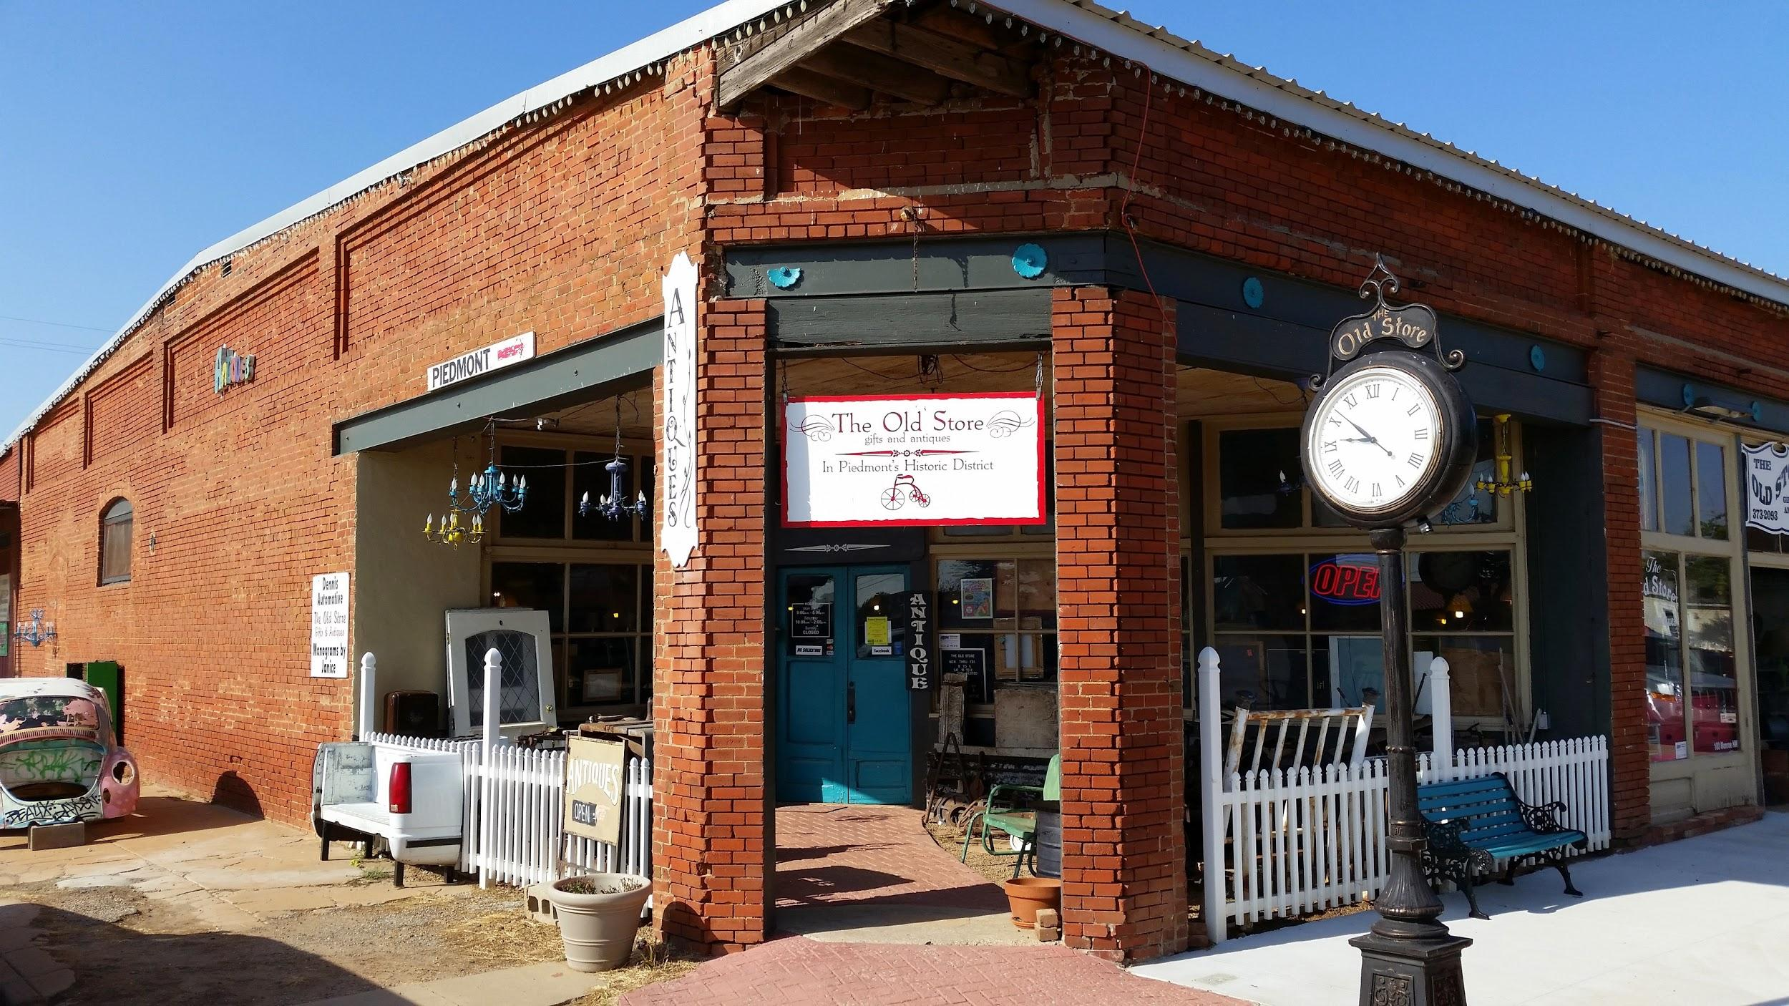
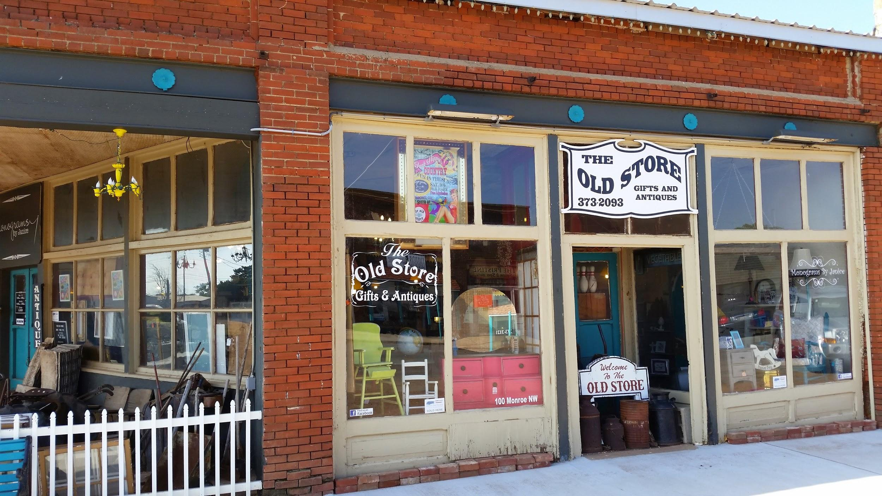

The Piedmont State Bank was the second brick building in town after the Mulvey Mercantile Company building and was the first two story brick building in Piedmont (and is still Piedmont’s only two story brick business building). Its first floor was utilized for the bank, but the second floor was utilized for members of the AF and AM lodges and began to be used for other uses as well. Ultimately, it what would become the Piedmont Historical Society building to commemorate our illustrious history. I will try to show you inside the historical museum if we have time while you're visiting. This bank moved to El Reno, a new bank called Rolling Hills State Bank took over, but eventually Farmers and Merchants Bank took over banking in Piedmont in 1989. They continue to serve us today under the illustrious leadership of Eric Anderson (one of the Piedmont Park Project PPP founders) and his extended family.
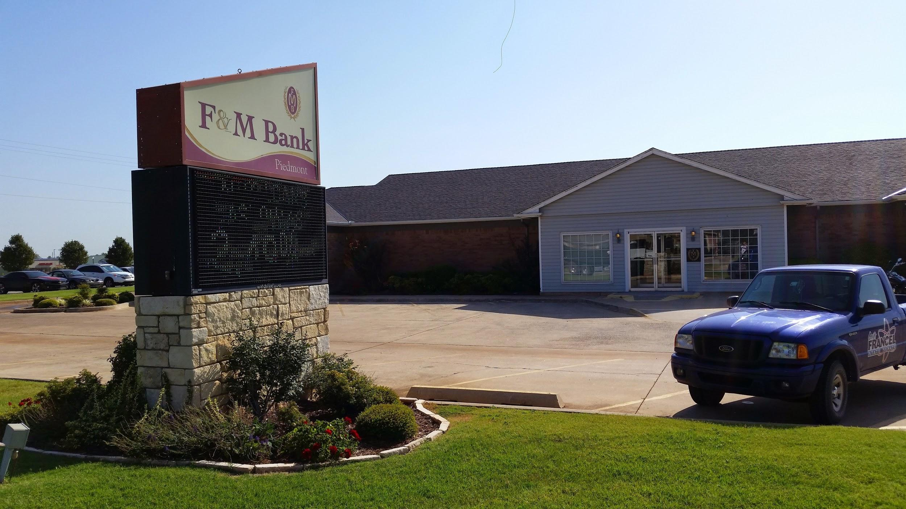
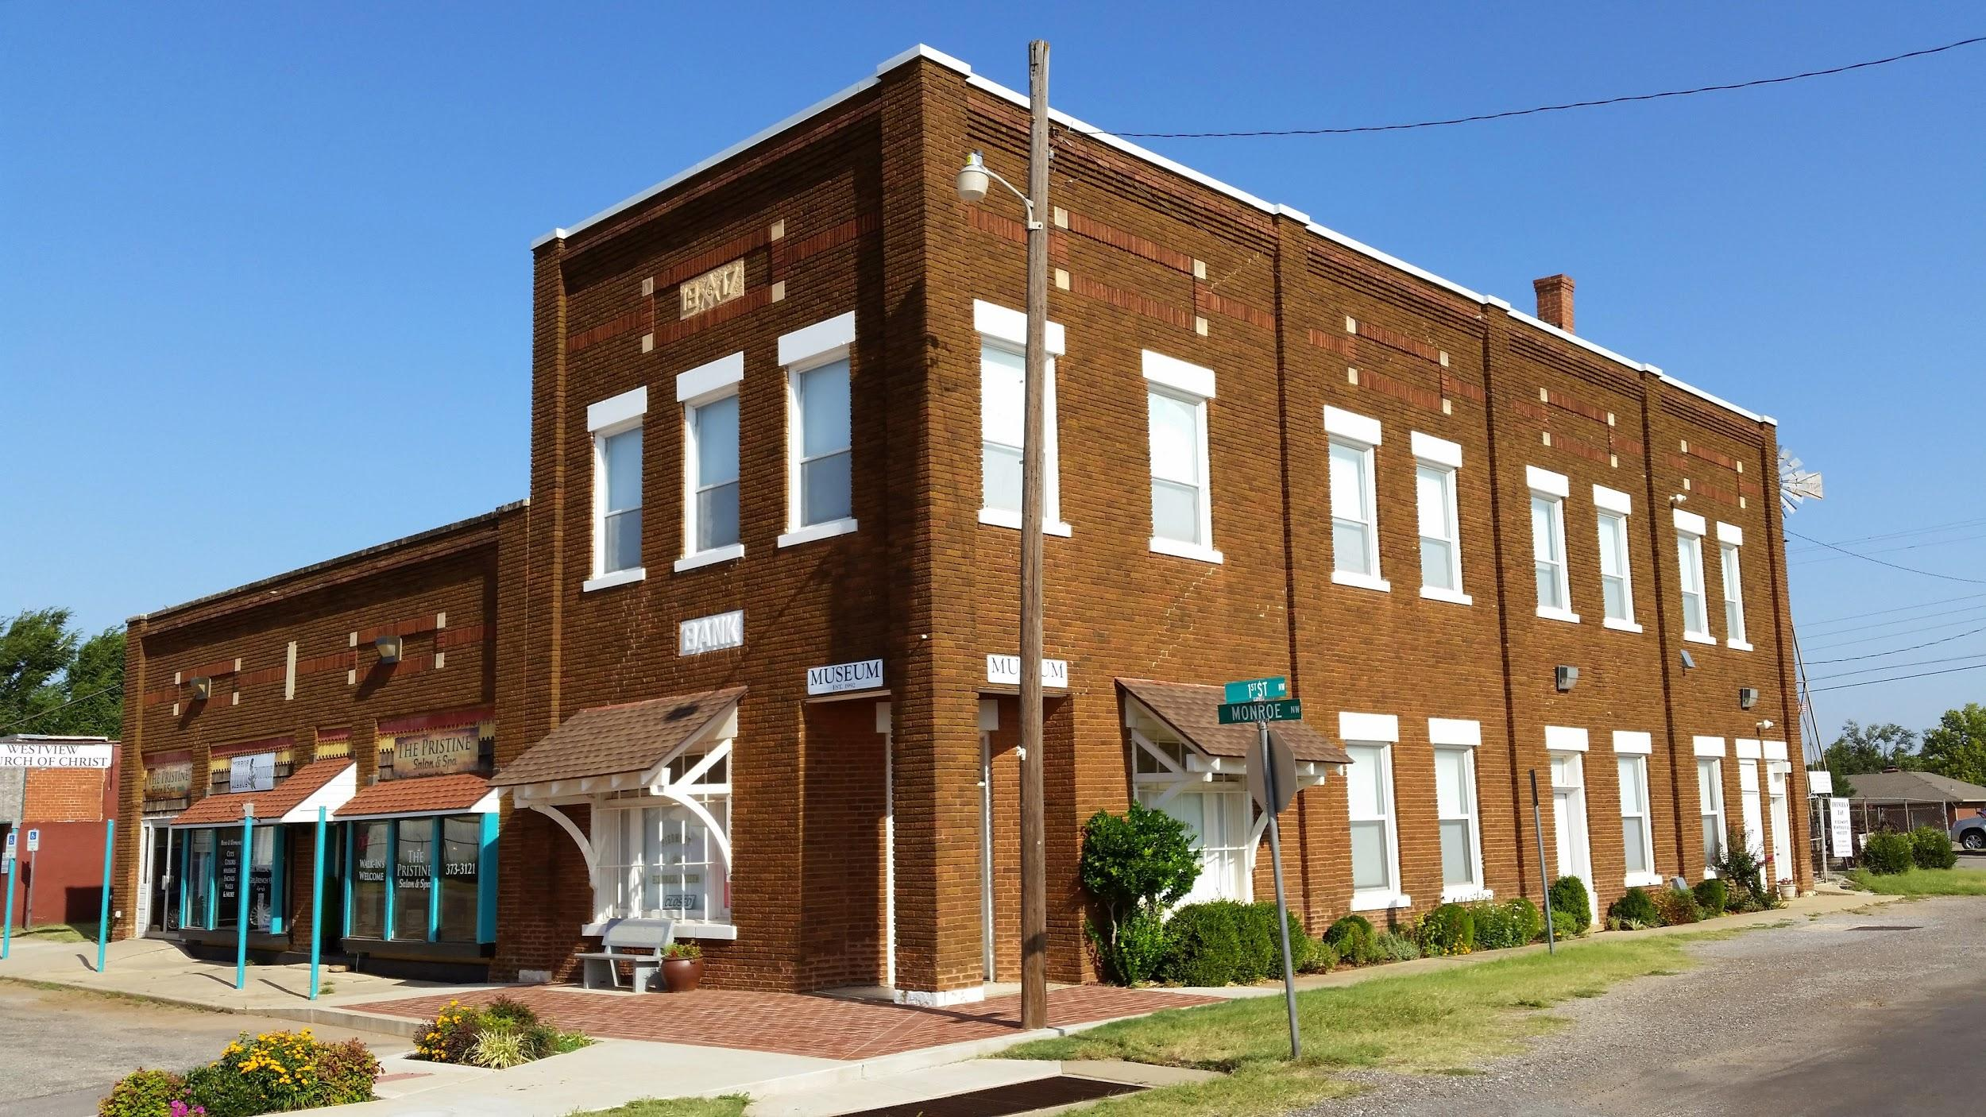

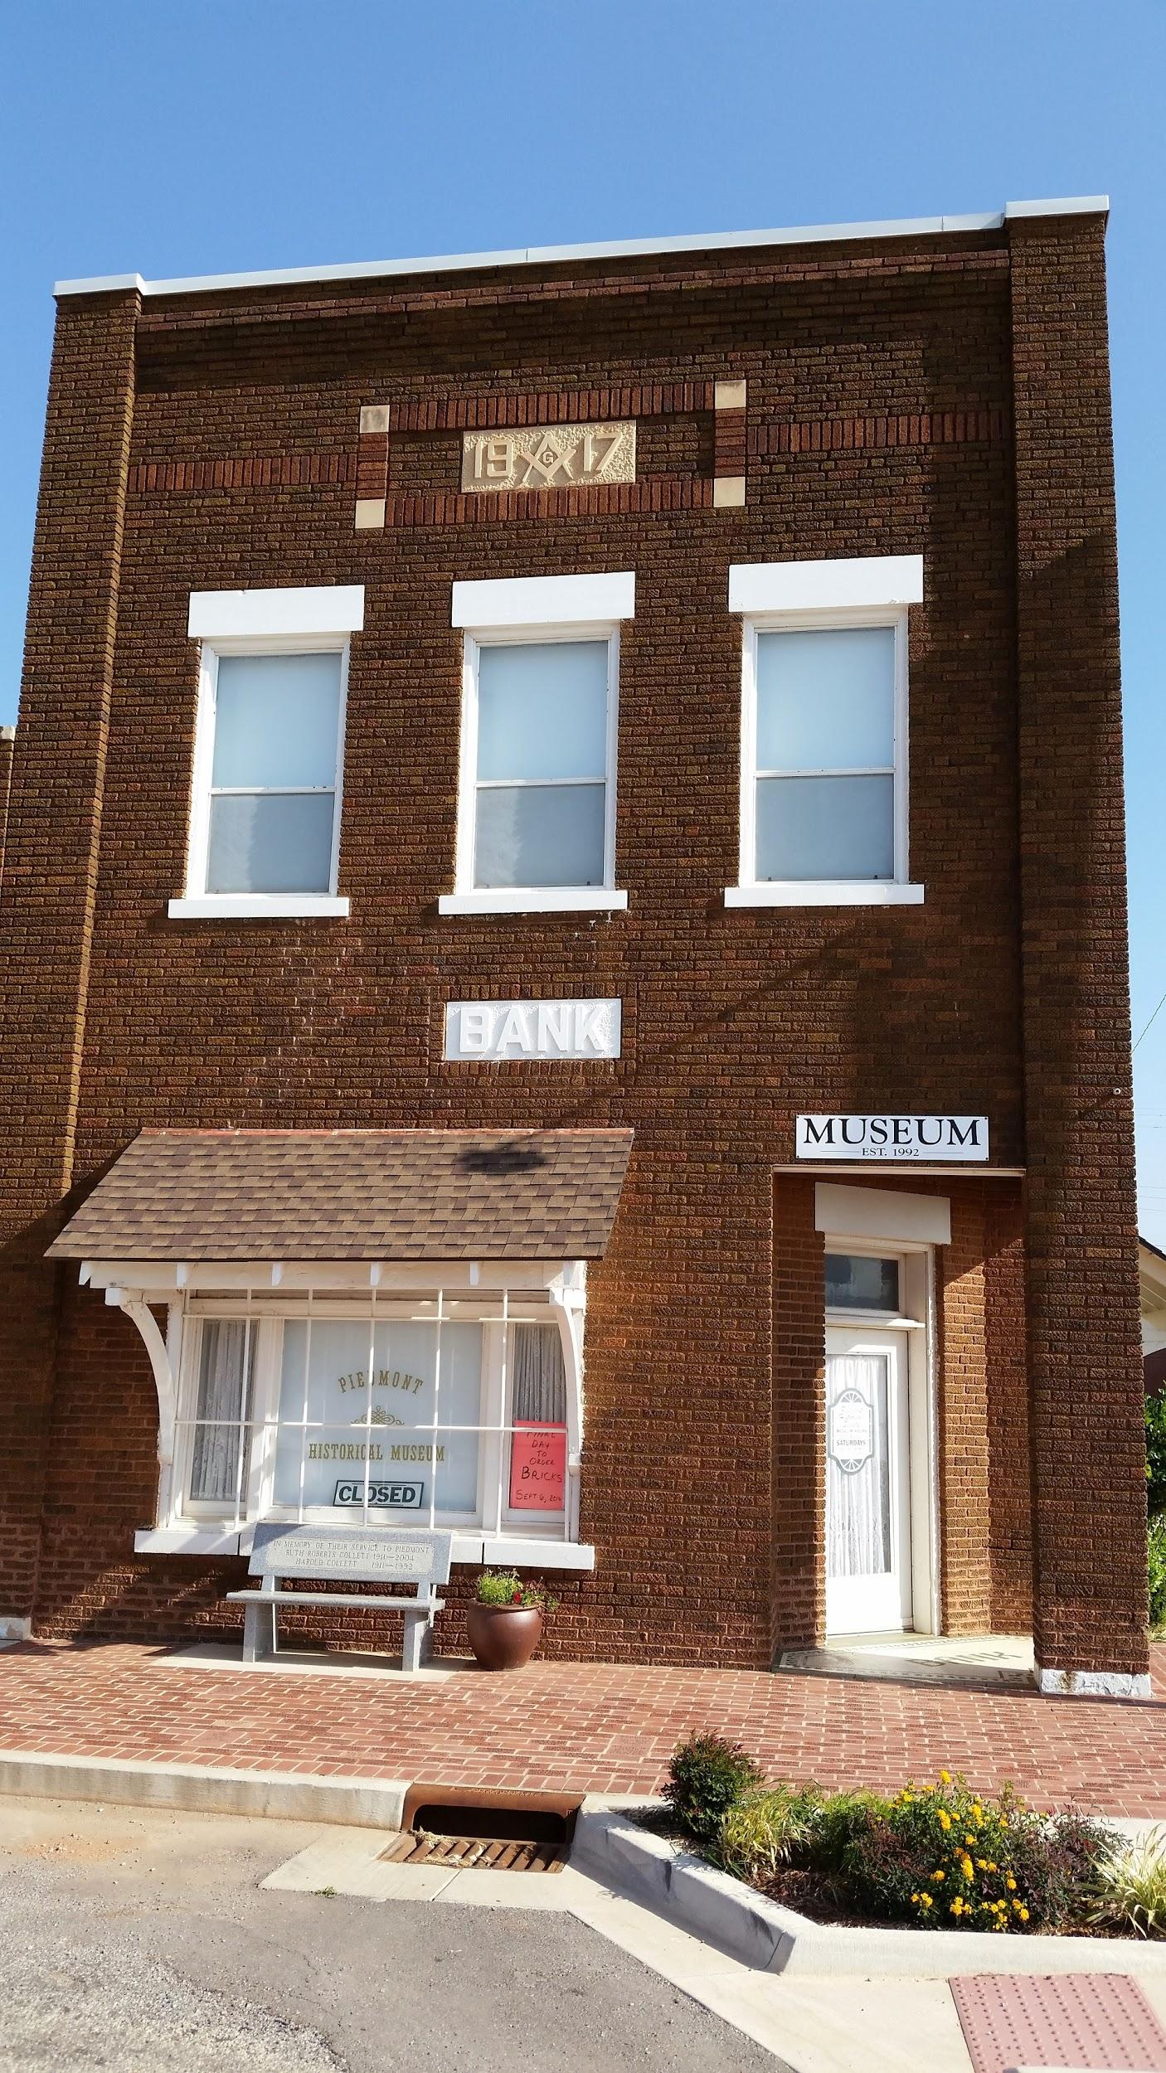

Stover Hall was quite a unique site though it is now longer in existence. Even though it was not in the center of town physically, it played a very important role in the social life of Piedmont citizens from the 1940s to the 1960s. The building was located on Northwest Highway five miles west of Piedmont Road, and actually consisted of two old school buildings moved to the site and merged into one building. The hall specialized in square dance lessons, private parties, good music, and wonderful atmosphere. Many of the Piedmont old-timers' ancestors of the town played in the band or hung out there. As I mentioned before, Vince Gill, son of Stanley Gill who played banjo with the Stovers, wrote a song that commemorates Herman Stover’s violin playing at the hall. The song is called “Old Time Fiddle.” I'll show you the song and the violin when you're here.

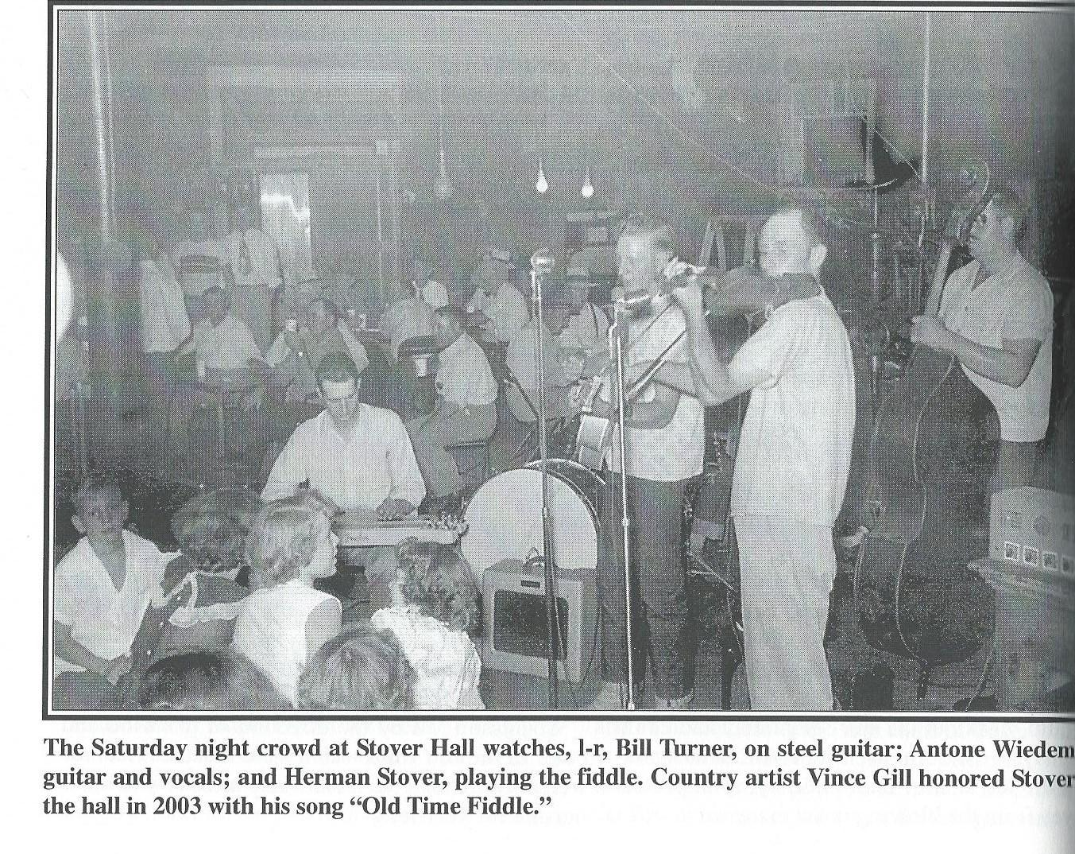
I can show you some of the details of the churches. One of the first founding churches still alive today includes the Piedmont Methodist Church which began in 1903. I found it interesting that when the church was founded it began as a Methodist Church because many of its members were actually members of numerous other denominations. It moved from its current site after being taken down and a new United Methodist Church was built approximately 10 years ago. The First Baptist Church was started in December of 1906. It began as a small church building that was heated by a potbelly stove that burned wood, and its charter membership of 18 members has become a church that has well over 1500 members today. The Bethel Free Methodist Church was located in a separate section of Piedmont (northeast area) beginning in the Pleasant View schoolhouse. It actually began in 1896 and the new building was begun in 1901. It was closed in the 1960's when many of the second and third generation individuals left their farms and began to go to Oklahoma City to the United Methodist Churches there.

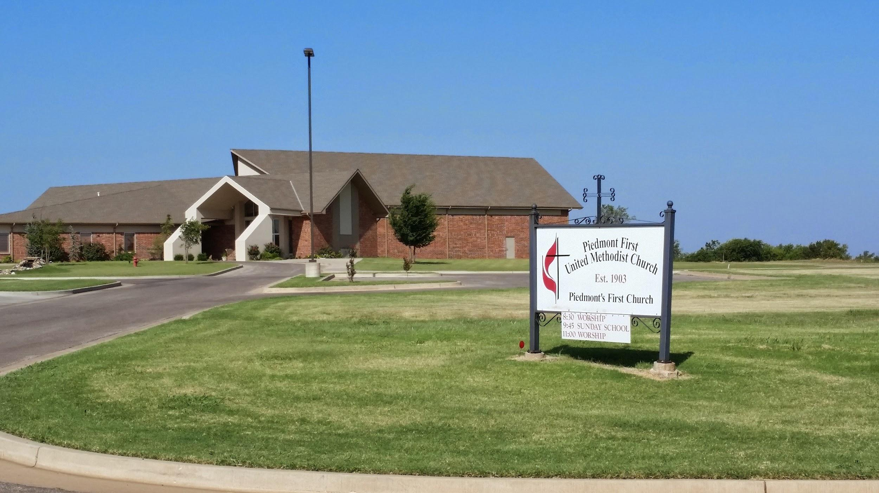
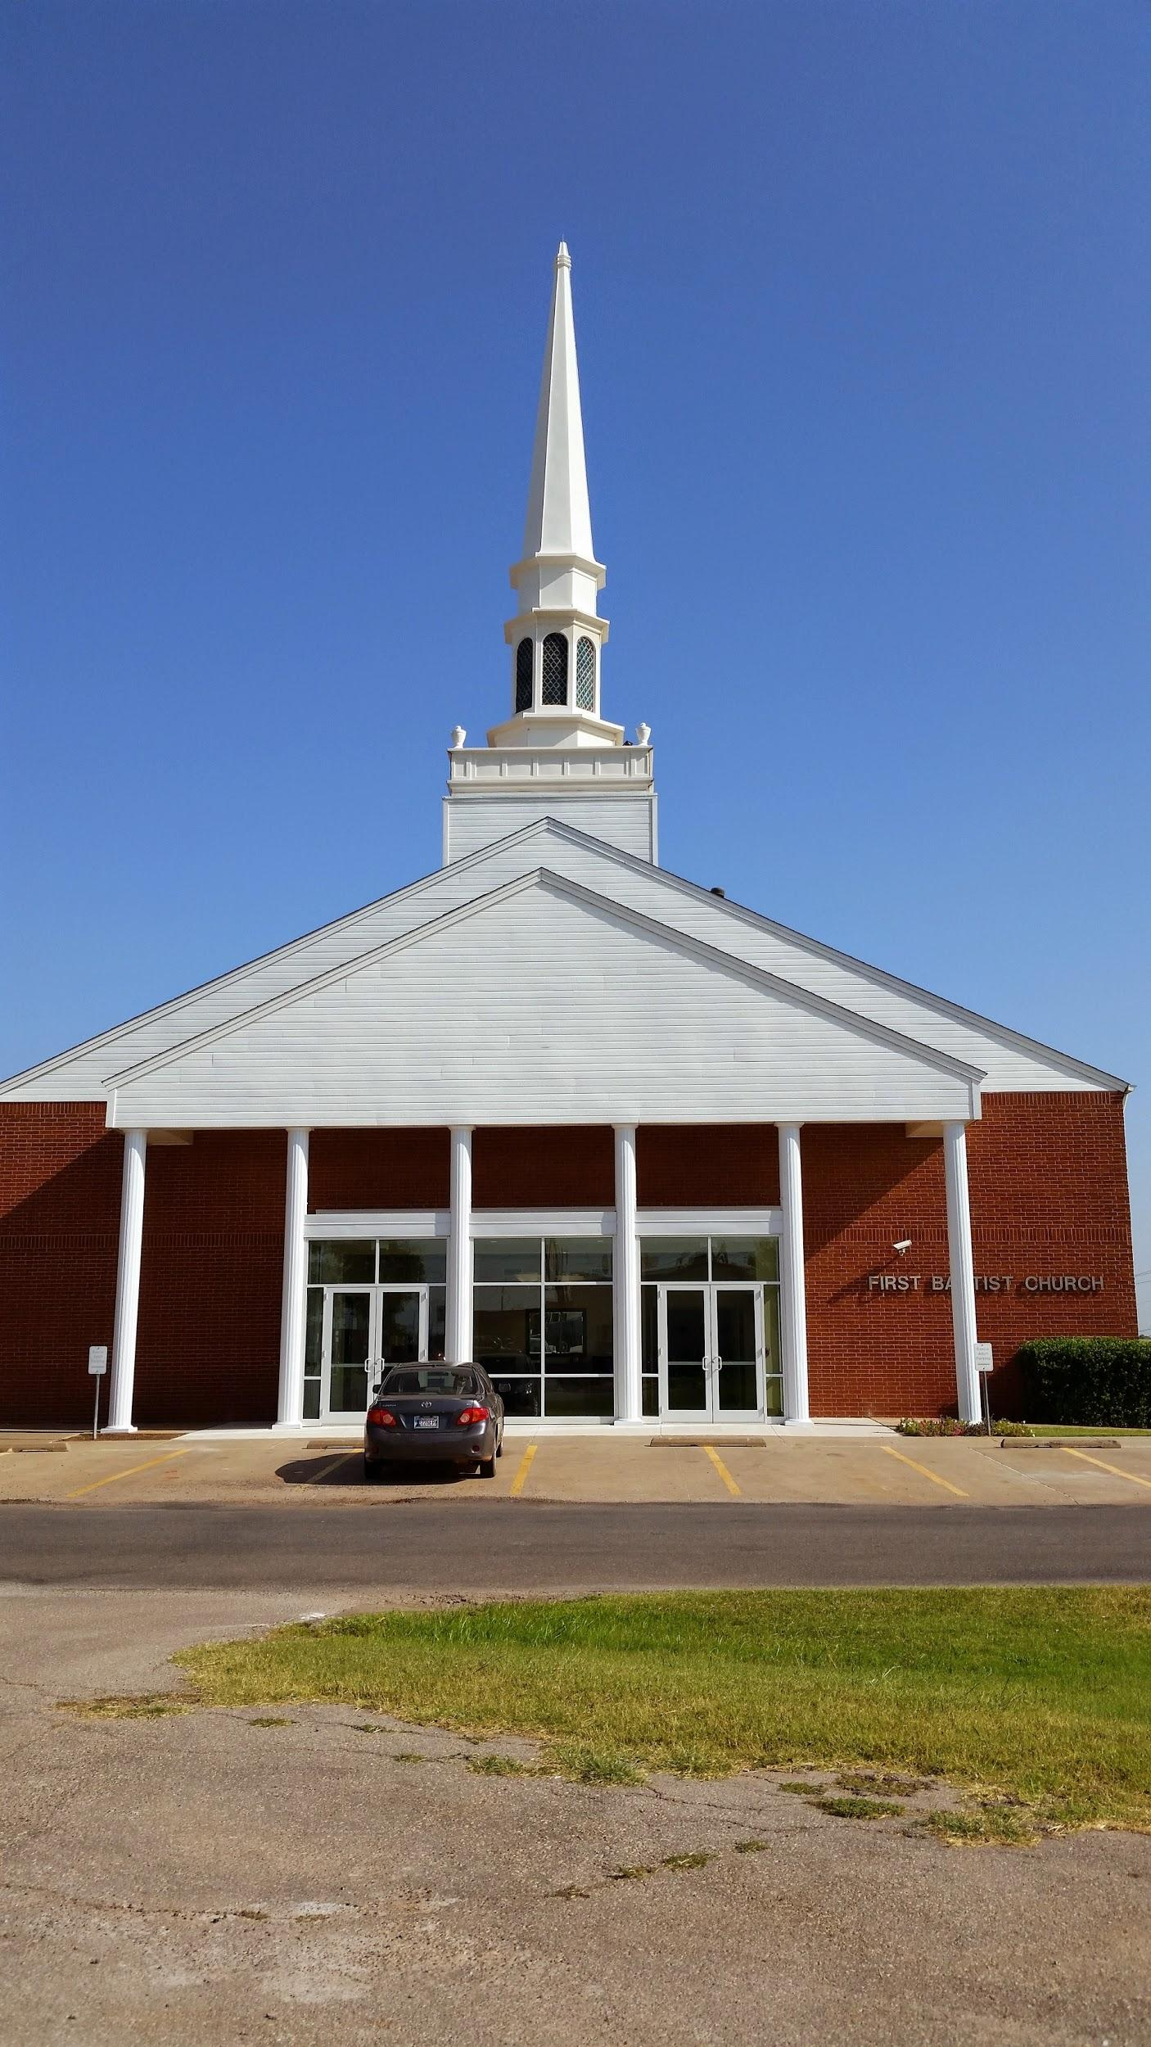

The Piedmont Surrey Gazette is a paper that has persisted since April of 1976. It followed the presence of several other newspapers that preceded it . Most importantly, the paper was owned by several long-term residents of Piedmont including Robert Funk, John and Cecilia Yager, Alan and Patsy Moffat, and Ken and Jan Dickerson. It continues to provide excellent news for our town both in a printed as well as an online version.

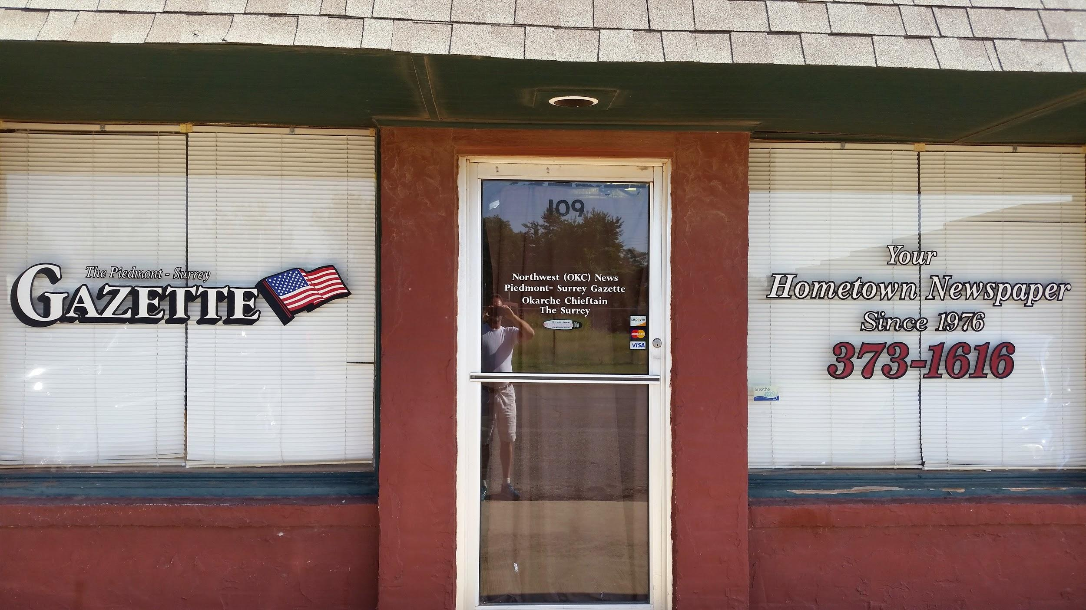

Piedmont Public Schools have been rated one of the best in the state, receiving an A rating in its evaluations. It provides excellent education both for college preparatory as well as industry-related careers. In terms of buildings, I've listed most notably Simpson Hall which was built in 1955 and Colette Field House which was built in 1977.

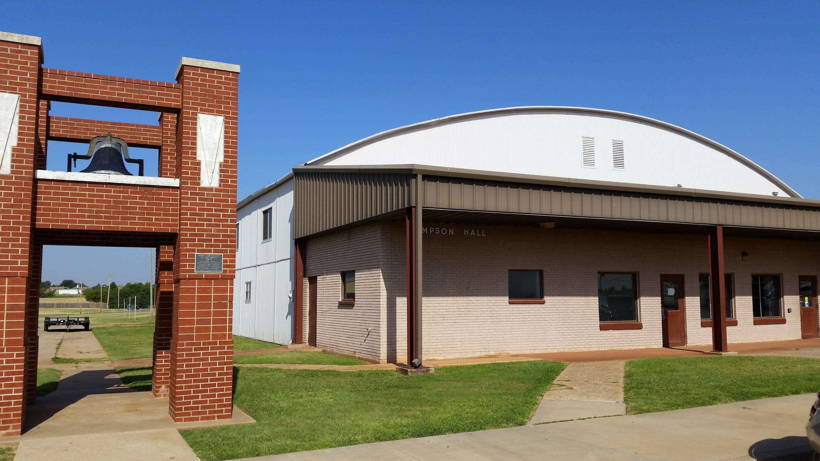
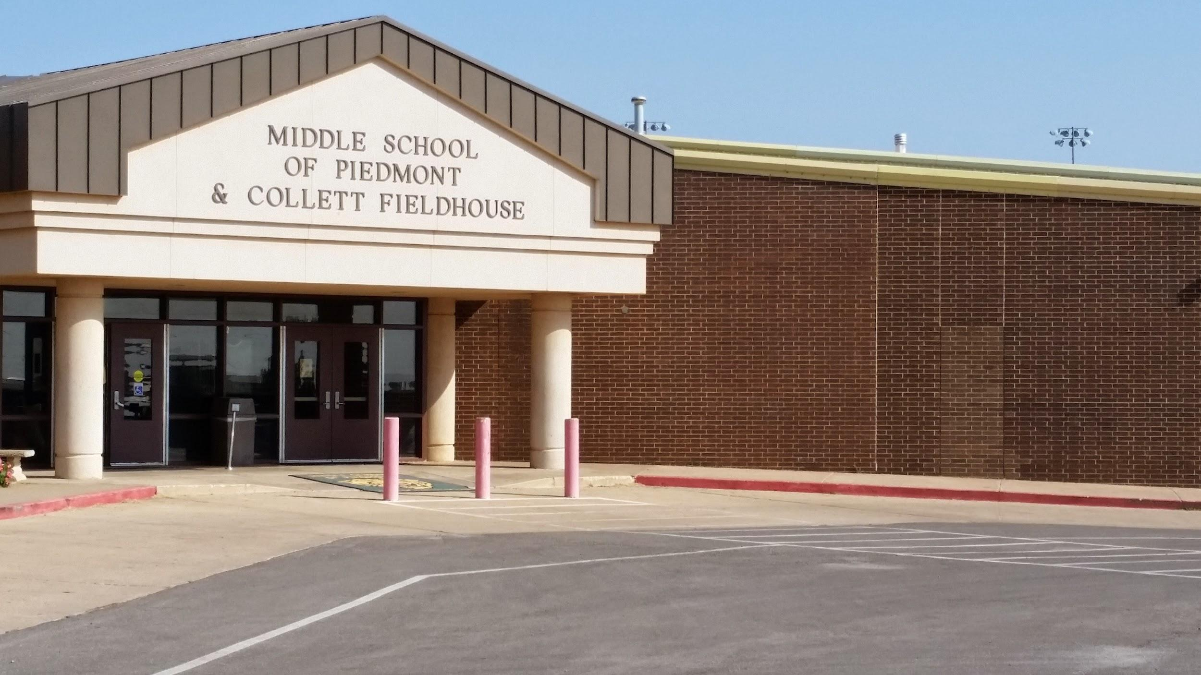

The windmill display project and the Piedmont slogan “Winds of Progress” was created in 1992. A group of citizens that were the central civic leaders of the town met together and were able to not only get windmills from around the Midwest but also to create a beautiful sign as people entered Piedmont through its main entrance on highway 4. The project was completed in December of 2002.

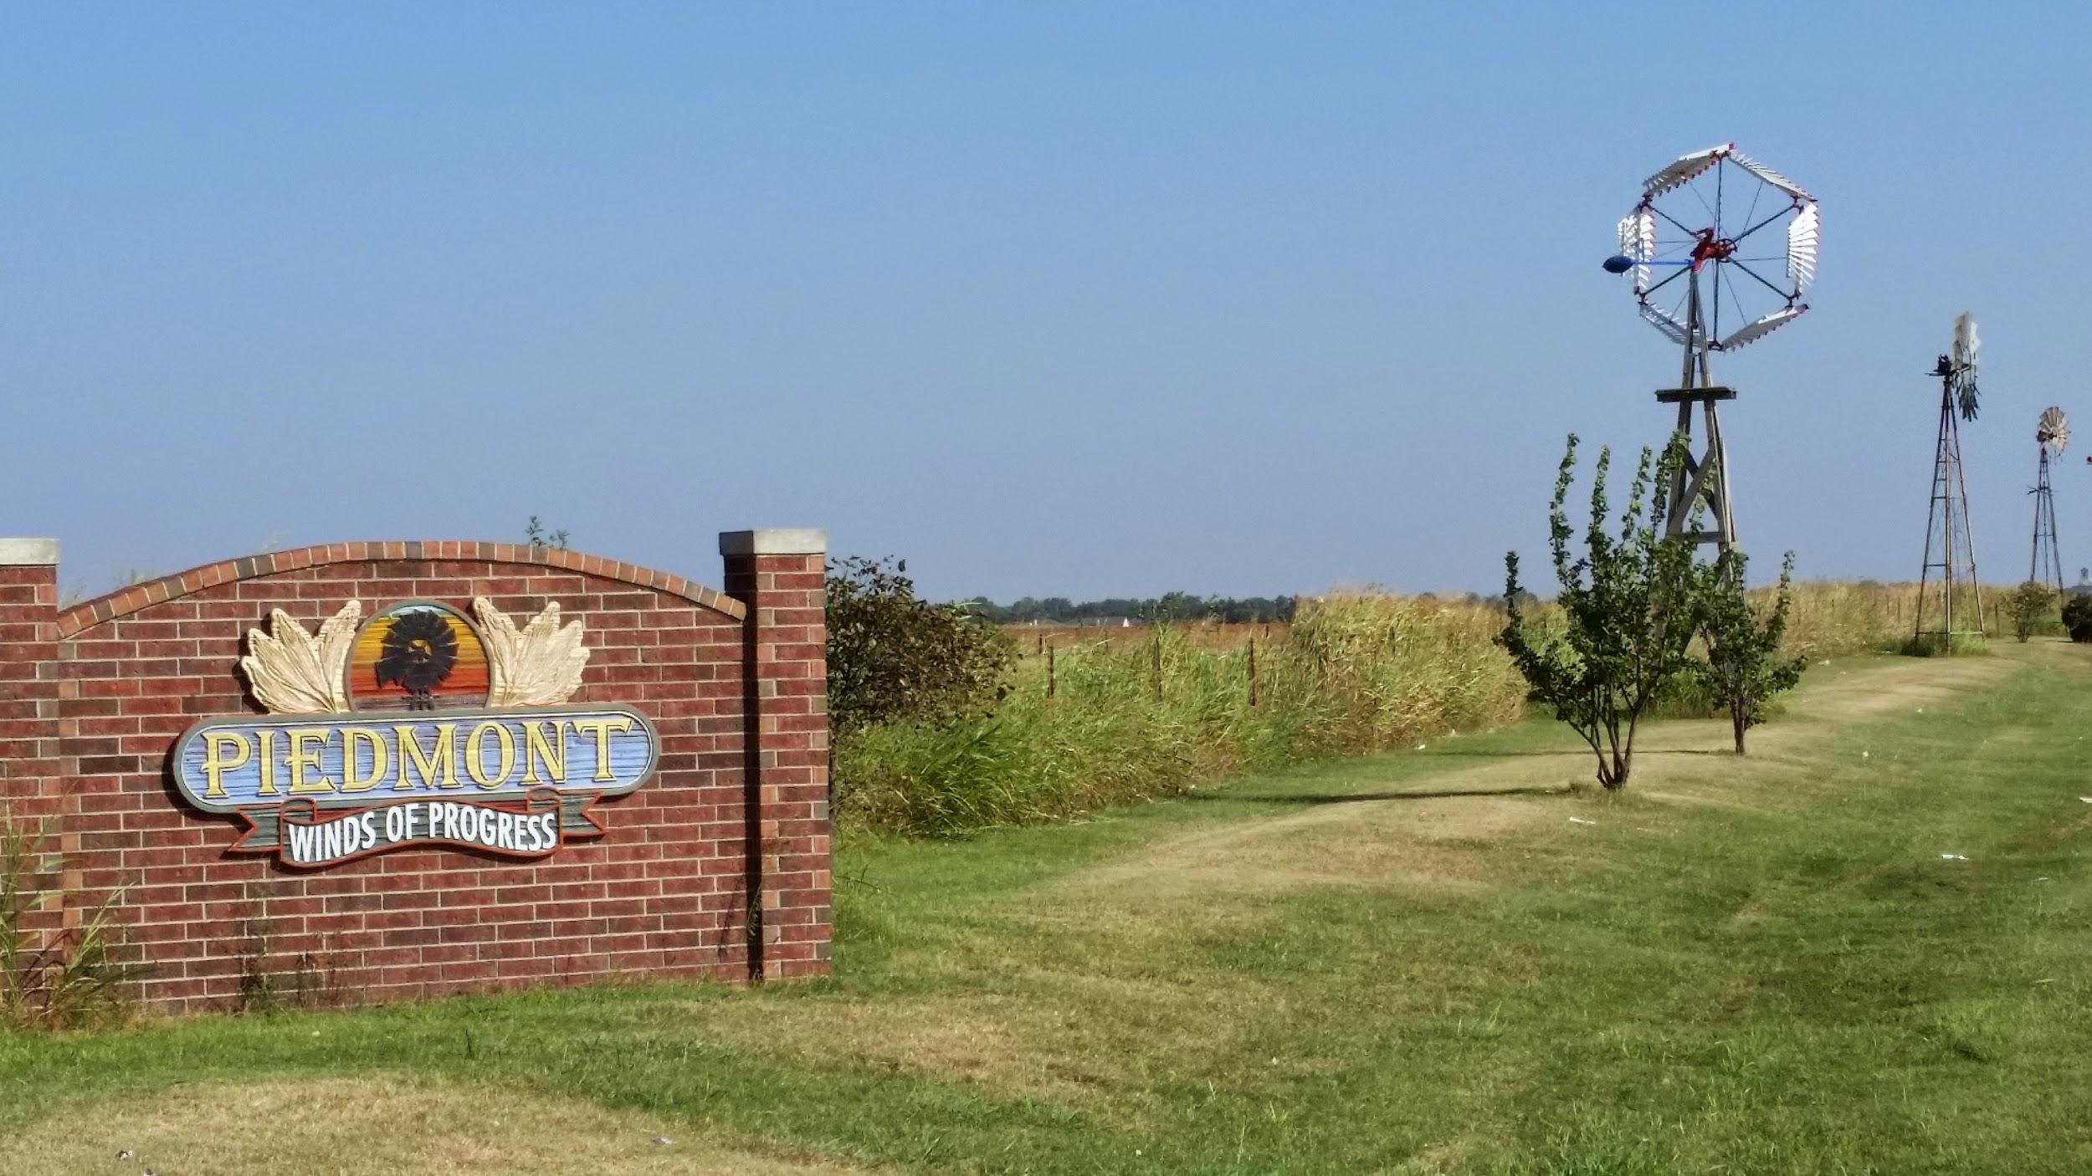
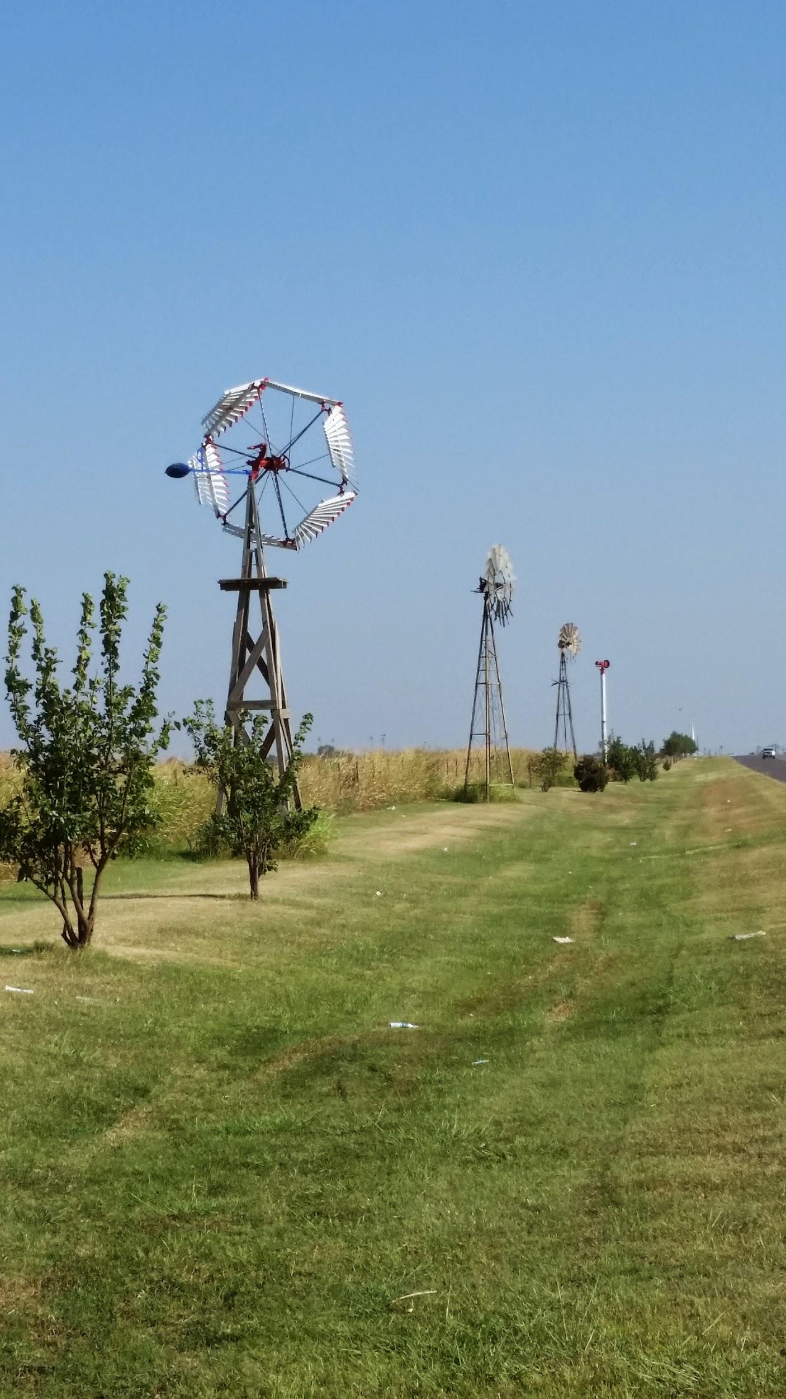

The sixth and final symbol or character is Founder’s Day. Founder's Day began in 1991 as a free barbecue of local farmer beef and lamb that was held at Collett Fieldhouse that served more than 500 people. After the initial success in 1991, they decided to have an annual celebration to honor the town's ancestors on the weekend after Labor Day. It is the central holiday for the town outside of the Fourth of July and other Christian holidays. Many events happen from about 10 am until 4 or 5 in the afternoon. Included in the festivities are such events as carnival rides, wagon rides with historical narration, craft shows, live entertainment, petting zoos and pony rides, many food booths, a children's theater presentation, and many games for the children. It also has a “kiss a pig” contest and various fundraisers created so that organizations can make money for their causes for the upcoming year.
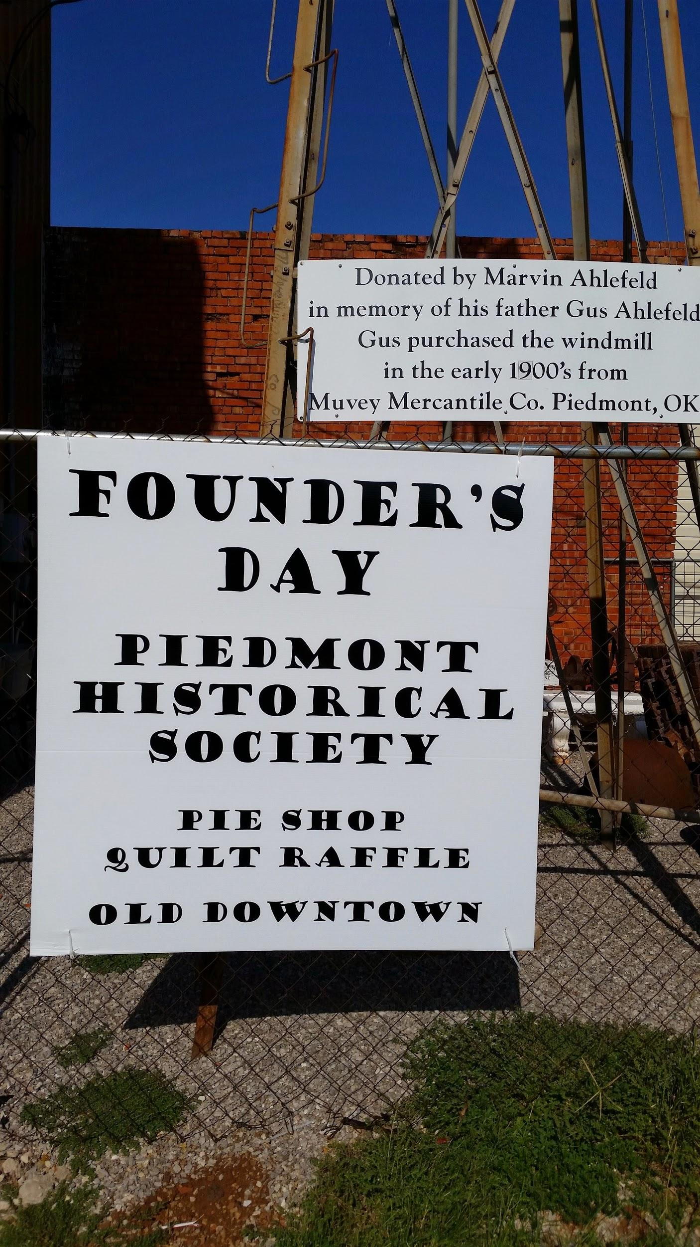
I hope this gives you a good idea of the history of Piedmont. Clearly many organizations played a role in the town’s development. It’s an ideal setting for owning a home, as well as its excellent school system, plus its proximity to OKC, all have contributed to Piedmont’s growth and its history. Piedmont has been rated “The Best City to Raise your Family in Oklahoma,” “The Best Place to Buy a Home in Oklahoma,” and the second fastest growing community in Oklahoma. It is a great place to live, to go to school, and to work. Clearly, the town has many civic and service organizations all of which contribute to the excellence of the town as well.
Piedmont has been craving a park, a place to relax, to have fun, to do “family” things, to play with the kids, to have young people congregate, to watch shows. It wants a place where it can teach its rich history to its wonderful families of today, and “Where Community Becomes Family,” the new motto for the Park. The Piedmont Park Project was therefore created in order to fulfill these dreams, and it is partnering with the city of Piedmont to make this dream a reality.

